DEPARTMENT OF CSE, CS&IT, AI&DS 2400033097 B.Vasavi
COURSE CODE: 24SDCS02 / 24SDCS02E / 24SDCS02P / 24SDCS02L
FULL STACK APPLICATION DEVELOPMENT
Date of the Session: / / Time of The Session: to
#SKILL - 5 Spring Autowiring Demo using @Autowired
Prerequisites:
- General Idea on Spring Framework
- Modules of Spring Framework
- Understanding of Autowiring concepts
A college application maintains student information along with their certification details. The Student object contains a Certification object, and instead of creating this Certification object manually, Spring should automatically provide it using the @Autowired annotation. When the required classes are marked with @Component, Spring creates their objects and manages them inside the IoC container. Using @Autowired, the Certification object is supplied to the Student object by Spring without using the new keyword, allowing both objects to be linked through annotation-based configuration.
Tasks:
- Create a Certification class with fields such as id, name, and dateOfCompletion.
- Create a Student class with fields such as id, name, gender, and a Certification object.
- Annotate both classes with @Component to enable Spring detection.
- Use @Autowired on a field, constructor, or setter inside the Student class to inject the Certification object.
- Configure component scanning using either:
  - An XML configuration file
A Java configuration class with @Configuration and @ComponentScan
- Load the Spring IoC container using ApplicationContext.
- Retrieve the Student bean and print all details, including the injected Certification object.
- Push the Spring project to GitHub.

Project Structure:
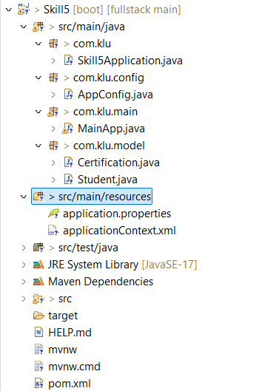

Skill5Application.java
package com.klu;
import org.springframework.boot.SpringApplication;
import org.springframework.boot.autoconfigure.SpringBootApplication;
@SpringBootApplication
public class Skill5Application {
public static void main(String[] args) {
SpringApplication.run(Skill5Application.class, args);
}
}
AppConfig.java
package com.klu.config;
import org.springframework.context.annotation.ComponentScan;
import org.springframework.context.annotation.Configuration;
@Configuration
@ComponentScan(basePackages = "com.klu")
public class AppConfig {
}
MainApp.java
package com.klu.main;
import org.springframework.context.ApplicationContext;
import org.springframework.context.support.ClassPathXmlApplicationContext;
import com.klu.model.Student;
public class MainApp {
public static void main(String[] args) {
ApplicationContext context =
new ClassPathXmlApplicationContext("applicationContext.xml");
Student student = context.getBean(Student.class);
student.displayDetails();
}
}

Certification.java
package com.klu.model;
import org.springframework.stereotype.Component;
@Component
public class Certification {
private int id;
private String name;
private String dateOfCompletion;
public Certification() {
this.id = 101;
this.name = "Java Full Stack";
this.dateOfCompletion = "15-01-2025";
}
@Override
public String toString() {
return "Certification [id=" + id +
", name=" + name +
", dateOfCompletion=" + dateOfCompletion + "]";
}
}
Student.java
package com.klu.model;
import org.springframework.beans.factory.annotation.Autowired;
import org.springframework.stereotype.Component;
@Component
public class Student {
private int id;
private String name;
private String gender;
@Autowired
private Certification certification;
public Student() {
this.id = 1;
this.name = "Vasavi";
this.gender = "Female";
}
public void displayDetails() {
System.out.println("Student ID : " + id);
System.out.println("Student Name : " + name);
System.out.println("Gender : " + gender);
System.out.println("Certification : " + certification);
}
}

applicationContext.xml
<?xml version="1.0" encoding="UTF-8"?>
<beans xmlns="http://www.springframework.org/schema/beans"
xmlns:xsi="http://www.w3.org/2001/XMLSchema-instance"
xmlns:context="http://www.springframework.org/schema/context"
xsi:schemaLocation="
http://www.springframework.org/schema/beans
http://www.springframework.org/schema/beans/spring-beans.xsd
http://www.springframework.org/schema/context
http://www.springframework.org/schema/context/spring-context.xsd">
<!-- Scan SAME base package -->
<context:component-scan base-package="com.klu"/>
</beans>

pom.xml
<?xml version="1.0" encoding="UTF-8"?>
<project xmlns="http://maven.apache.org/POM/4.0.0" xmlns:xsi="http://www.w3.org/2001/XMLSchema-instance"
xsi:schemaLocation="http://maven.apache.org/POM/4.0.0 https://maven.apache.org/xsd/maven-4.0.0.xsd">
<modelVersion>4.0.0</modelVersion>
<parent>
<groupId>org.springframework.boot</groupId>
<artifactId>spring-boot-starter-parent</artifactId>
<version>4.0.2</version>
<relativePath/> <!-- lookup parent from repository -->
</parent>
<groupId>com.klu</groupId>
<artifactId>spring-di</artifactId>
<version>0.0.1-SNAPSHOT</version>
<name>Skill5-</name>
<description>Demo project for Spring Boot</description>
<url/>
<licenses>
<license/>
</licenses>
<developers>
<developer/>
</developers>
<scm>
<connection/>
<developerConnection/>
<tag/>
<url/>
</scm>
<properties>
<java.version>17</java.version>
</properties>
<dependencies>
<dependency>
<groupId>org.springframework.boot</groupId>
<artifactId>spring-boot-starter</artifactId>
</dependency>
<dependency>
<groupId>org.springframework.boot</groupId>
<artifactId>spring-boot-starter-test</artifactId>
<scope>test</scope>
</dependency>
</dependencies>
<build>
<plugins>
<plugin>
<groupId>org.springframework.boot</groupId>
<artifactId>spring-boot-maven-plugin</artifactId>
</plugin>
</plugins>
</build> </project>
Output:
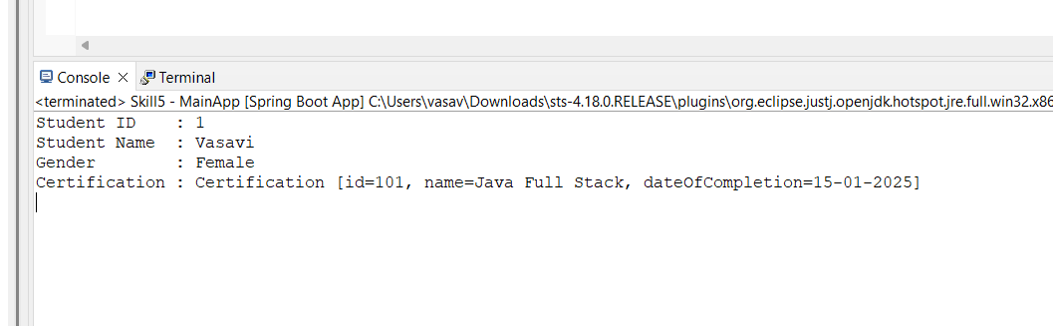

VIVA QUESTIONS:

- What is autowiring in Spring?
- What is the purpose of the @Autowired annotation?
- How does Spring choose which bean to inject?
- What is component scanning in Spring?
- What happens if more than one bean matches the dependency type?

1Ans: Autowiring is a feature in Spring where the framework automatically injects dependencies into a bean without explicit configuration.
2Ans: @Autowired tells Spring to automatically inject the required dependency into a constructor, setter, or field.
3Ans: Spring injects a bean based on type by default. If multiple beans of the same type exist, it checks for qualifiers or bean names.
4Ans: Component scanning is a mechanism where Spring automatically detects and registers classes annotated with @Component, @Service, @Repository, or @Controller.
5Ans: Spring throws a NoUniqueBeanDefinitionException unless @Qualifier or @Primary is used to specify which bean to inject.

(For Evaluator’s use only)
Comment of the Evaluator (if Any)

Evaluator’s Observation
Marks Secured: out of
EMP ID & Full Name of the Evaluator:

Signature of the Evaluator Date of Evaluation:

